12/12/2023

**PROJECT REPORT**

**Group Member:**

1. **ABDUL QADOOS (LEADER)**
2. **ZOHAIB MAHAR**

TITLE:

QZ BANK MANAGEMENT SYSTEM USING C++

**TABLE OF CONTENTS**

1. Introduction

2. Objective

3. Libraries Used

4. Project Structure

5. Functionality Overview

6. Security Considerations

7. Screenshots

8. Conclusion

1. Introduction :-

The QZ Bank Management System is a C++ based project designed to simulate basic banking operations, allowing users to perform account creation, deposit and withdrawal of funds, check balances, and manage account information. The system is implemented using Object-Oriented Programming (OOP) principles and utilizes file handling for persistent data storage.

1. Objective :-

The primary objectives of the project are:

* To create a user-friendly banking system for educational purposes.
* To demonstrate the implementation of basic account management functionalities.
* To showcase the use of C++ programming language and relevant libraries.

1. Libraries Used :-

The project makes use of the following C++ libraries:

* <iostream>: Input and output stream handling.
* <fstream>: File input and output operations.
* <iomanip>: Input and output manipulation.
* <time.h>: Functions related to date and time.
* <stdlib.h>, <cstdlib>: General-purpose functions, including random number generation.
* <windows.h>: Windows API functions for console manipulation.
* <conio.h>: Console input/output functions (e.g., getch).
* <vector>: Container for dynamic arrays.
* <dos.h>: DOS-specific functions.

1. Project Structure:-

The project is organized into the following main components:

* Classes: The account class encapsulates account-related operations.
* Functions: Various functions handle account creation, modification, deletion, and display.
* File Handling: Account data is stored in a binary file ("account.dat").

1. Functionality Overview :-

The key functionalities of the QZ Bank Management System include:

* User authentication through a basic login system.
* Account creation, modification, and deletion.
* Deposit and withdrawal of funds.
* Displaying individual account details and a list of all accounts.

1. Security Considerations :-

The project features a simple login system for user authentication. However, it's essential to note that this system is for educational purposes and lacks robust security measures. In real-world applications, more secure authentication methods and data encryption would be necessary to ensure the confidentiality and integrity of user information.

1. Screenshots :-

Include relevant screenshots to showcase the user interface and key functionalities of the QZ Bank Management System. Provide captions for each screenshot to explain the context.

**Screenshot 1: Login Interface**

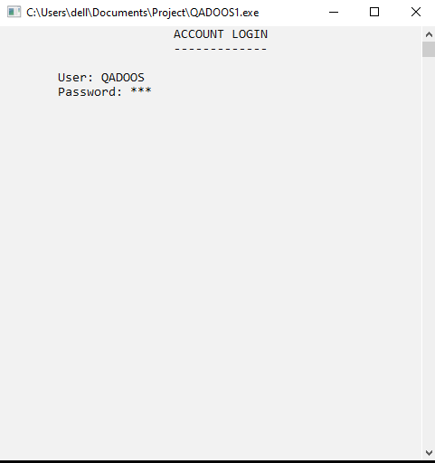

***Caption: The login interface where users enter their credentials****.*

**Screenshot 2: Main Menu**

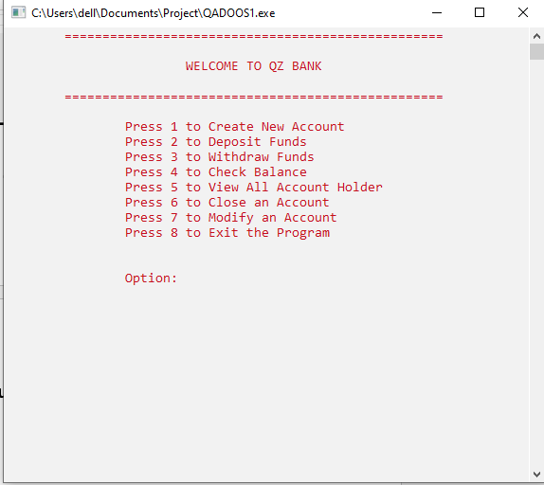

***Caption: The main menu displaying available banking operations.***

**Screenshot 3: Account Creation**

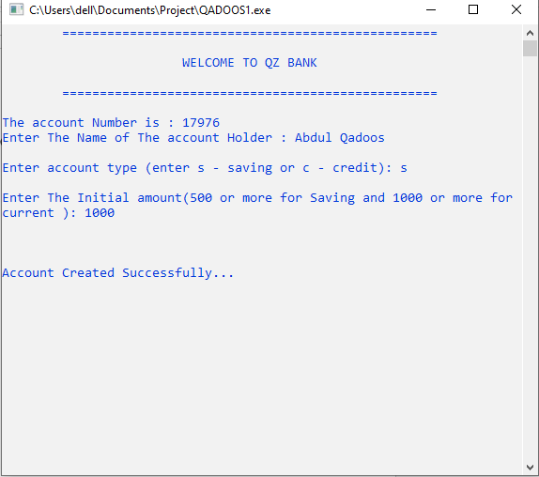

***Caption: The account creation screen where users can input details for a new account.***

**Screenshot 4: Individual Account Details**

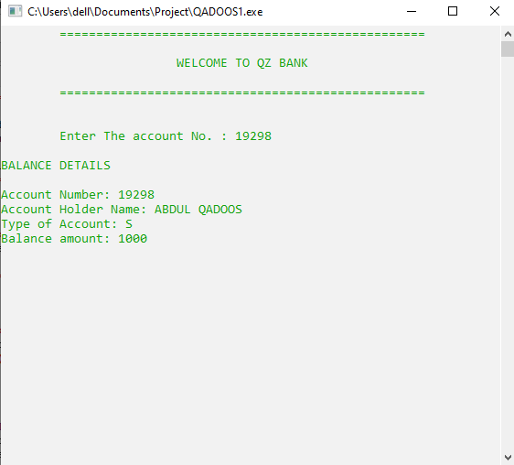

***Caption: Displaying details of an individual bank account***

**Screenshot 5: Deposit Operation**

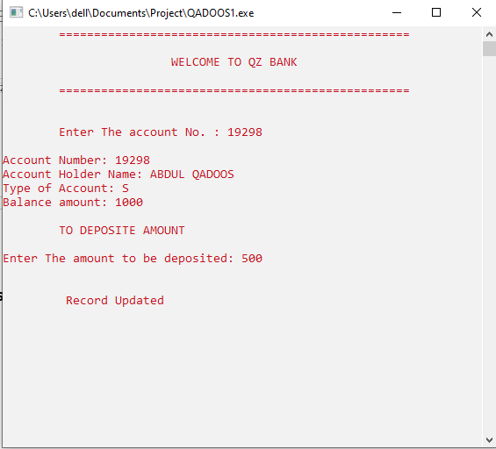

***Caption: Performing a deposit operation with the system***

**Screenshot 6: Withdrawal Operation**

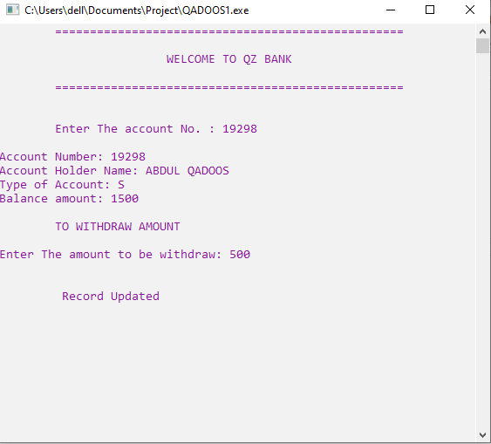

***Caption: Performing a withdrawal operation with the system.***

1. Conclusion :-

The QZ Bank Management System provides a basic yet functional implementation of a banking system in C++. It serves as a valuable educational resource for understanding fundamental concepts of programming, file handling, and basic account management.

This report covers the project's objectives, libraries used, project structure, key functionalities, and security considerations. Future enhancements could focus on improving security features, expanding functionality, and implementing a more sophisticated user interface.

**THANK YOU**

**Link of my project video on YouTube:-**

**Abdul Qadoos (Individual Link)**

Link YouTube Video:- https://youtu.be/Wl0qd-LRcYE